# JRD301: Mini Project in Robotics (Second Semester 2019‐20)

Weekly Progress Report (From: 06/01 /2020 To: 10/01/2019)

I undertake that the following work has been accomplished during the above mentioned period of one week (please write in bulleted points):

* We eliminated the zebra crossings detected to avoid its interference with lane detection.
* This was done by ignoring lines that were parallel to the road, i.e., had an absolute angle less than 5 radians.
* We reduced the noise observed in lane detection by ignoring lines which had an absolute angle difference greater than 20 radians with the line predicted by the Kalman filter for both left and right boundaries of the lane detected.
* We observed issues with the detection of heading direction using the frame of view. So we started looking at other methods for determining heading direction.

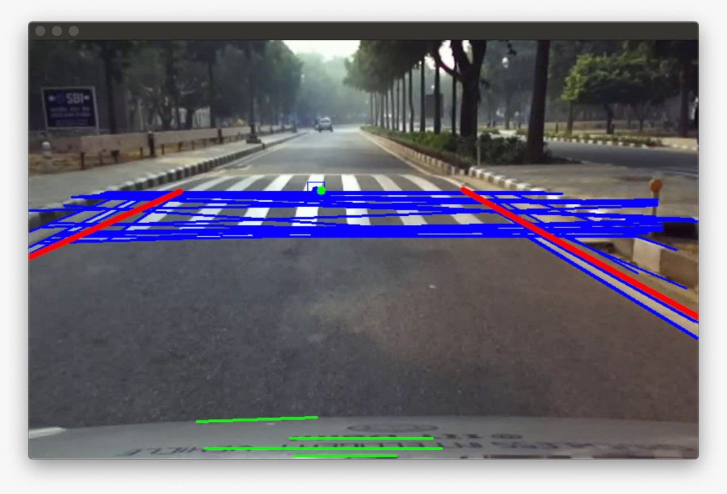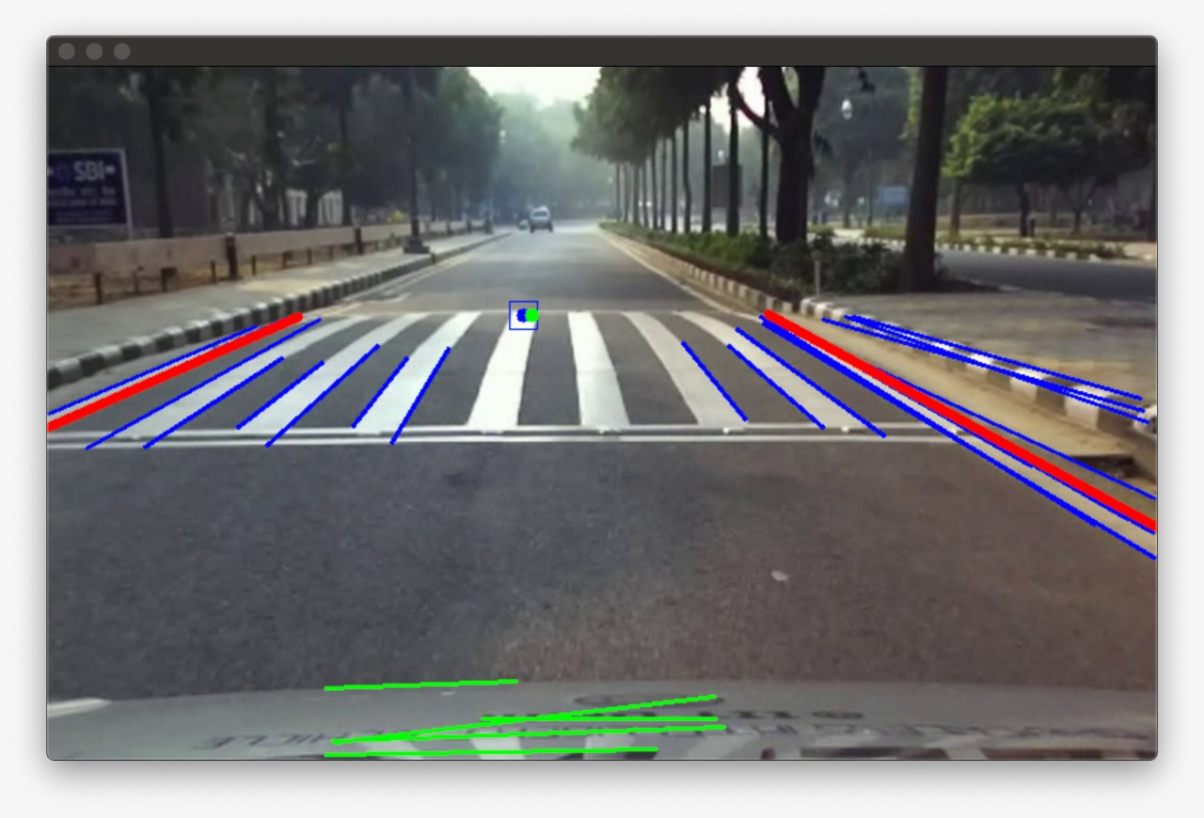

**A B**

*Fig 1: Zebra crossing detection*

*A) before elimination B) after elimination*

# Submitted by (student’s name with signature) Endorsed by:

Group member 1: Harman Mehta (2016BB50003) Supervisor 1: Prof. Sunil Jha

Group member 2: Tanmay Goyal (2016ME20757)